Updated in April 2025

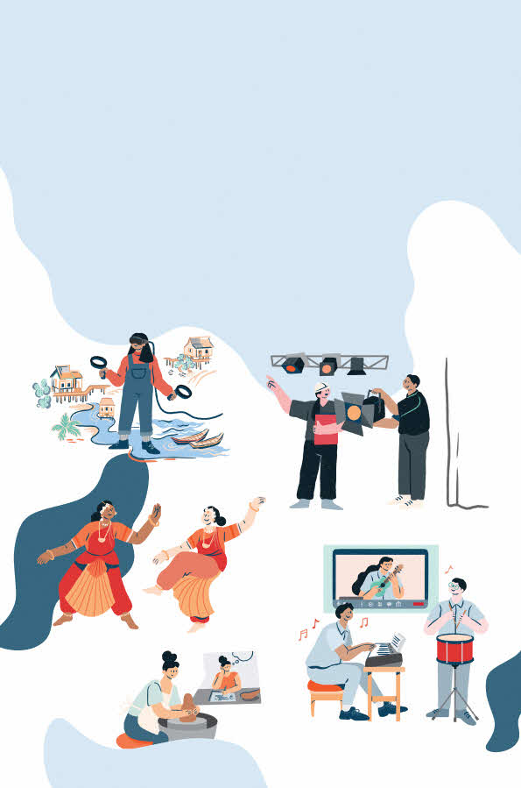
Programme Design Guide
Contents

- Introduction  - Arts Education Framework Overview.……………………….…………………………………………..………..  3 Focus Areas  Appreciate Arts & Culture  Acquire Skills & Knowledge  Articulate Thoughts & Ideas  5 Points of Emphasis  SG Cultural Identity  Arts x Tech  Industry Explorations  Life Skills  Arts & Society | 2  3
- NAC-AEP 2026 Cycle Key Features  More Intentional Design of Programmes  Wider Range of Arts Learning Experiences  More Opportunities for Customisation | 8
- Connections to Learning in Schools …………………………………………………………………………………  Pre-school  Mainstream (Primary and Secondary)  6 Art Forms (Dance, Literary Arts, Music, Theatre, Visual Art & Digital Media)  Character and Citizenship Education  Post-Secondary (Junior College, Millenia Institute, and Institute of Technical Education)  Special Education | 9
- Playing Our Part in Nurturing Future-Ready Learners ……………………………………………………..  Fostering 21st Century Competencies  Designing for Active Arts Learning  Leveraging Education Technology | 15

1. Introduction
The arts is an integral part of all Singaporeans’ lives, and exposure to the arts should begin from an early age to support a child’s holistic development, foster appreciation of other cultures, and seed the development of future arts professionals and audiences. To this end, the National Arts Council (NAC) is committed to providing all students with access to quality arts learning experiences to foster appreciation of the arts, acquire skills and knowledge about the arts and articulate their thoughts through the arts.
NAC Education Unit works closely with the arts community and various agencies, including the Ministry of Education (MOE), the Early Childhood Development Agency (ECDA) and schools, to provide access to a range of well-designed arts education experiences with Singapore artists and arts groups. It is through these broad-based efforts that students of all ages and abilities will develop a deep appreciation for Singapore culture, and grow to be confident, articulate, and creative individuals who will actively contribute to society.
In response to the changing education landscape, NAC Education Unit embarked on a strategic review in 2019 with the intention to ensure that arts education programmes offered by NAC continue to achieve desired education outcomes and remain relevant to the wide range of school profiles from pre-school to pre-tertiary levels. In 2020 and 2021, the COVID-19 pandemic prompted further revisions as the disruptions in learning environments reaffirmed the importance of arts learning across levels to foster social and emotional well-being and imbue resilience and national pride. The disruptions to in-school learning in those two years also focused attention on ensuring broad-based access to quality arts experiences by expanding beyond face-to-face learning formats.
The extended review process included scans of literature centred on arts education and holistic development as well as teaching and learning frameworks and syllabuses by MOE. NAC Education Unit also conducted dialogue sessions with various stakeholder groups to identify key factors in strengthening outcomes of arts learning experiences. This led to the development of an Arts Education Framework that would guide intentional programme design with clear learning outcomes that reflect shared priorities among NAC, MOE and the Arts Sector.
2. NAC Arts Education Framework Overview
NAC Arts Education Framework consists of 3 Focus Areas and 5 Points of Emphasis. The Framework sets out the desired learning outcomes of arts programmes, which in turn help to guide programme content design. Both the Focus Areas and Points of Emphasis are kept broad to provide flexibility for interpretation across programme types, art forms as well as student learning needs across levels and target profiles. Whilst there are natural overlaps across Focus Areas and Points of Emphasis, NAC encourages arts educators to identify the core intent of their programmes and thoughtfully select the relevant Focus Area(s) and Point of Emphasis (where applicable) that best define the desired learning outcomes of their programmes.
The purpose of this Framework is to:
- Define learning outcomes of arts programmes;
- Guide intentional design and delivery of arts programmes; and
- Scope key concepts and/or skills for lesson plan.

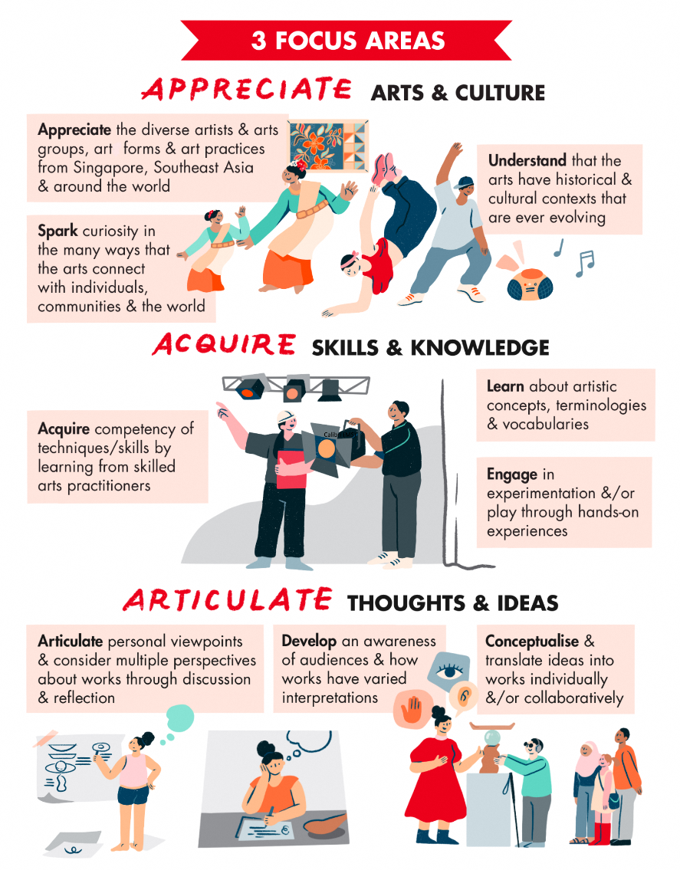
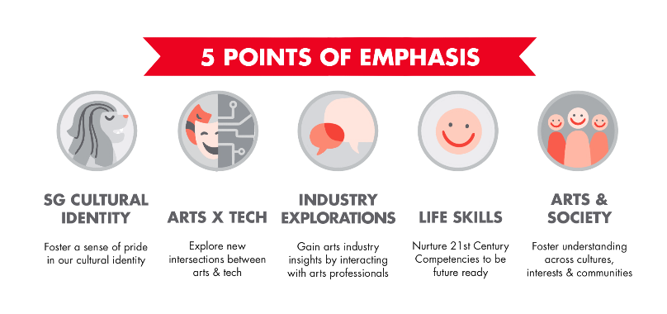

3 Focus Areas
Appreciate Arts & Culture
Participation in artist-led arts programme can spark students’ curiosity about the arts and provide fresh perspectives that expand/deepen their learning in schools. Programmes designed to address this Focus Area will provide opportunities for students to:
- Appreciate the diverse artists and arts groups, art forms and arts practices from Singapore, Southeast Asia and around the world
- Spark curiosity in the many ways that the arts connect with individuals, communities and the world
- Understand that the arts have historical and cultural contexts that are ever evolving
Considerations:
- How might we encourage students to reflect on how artists portray arts and culture of a community and/or country in their artworks/performance/story, etc.
- How might we encourage students to be active viewers while watching a performance or listening to a talk? (E.g. students can pose questions to performers via an online collaborative bulletin board such as Padlet and Miro)
- How might we spark curiosity during a programme? (E.g. during an excursion to public arts, provide opportunities for hands-on learning or play rather than simply listening to the guide)
- What kind of resources can we provide to encourage students to continue in self-directed learning after the programme ends? (E.g. provide handouts with links to websites for extended learning about art practices in Southeast Asia)

Acquire Skills & Knowledge
Listening to and learning directly from skilled arts practitioners who are also passionate about education can be inspiring to a young person. Building on the many skills and talents that students bring into the classroom, arts learning from practising artists can provide new perspectives, safe spaces for experimentation and/or play. Programmes designed to align with this Focus Area will encourage students to:
- Acquire competency of specific techniques/skills by learning from skilled arts practitioners
- Learn artistic concepts, terminologies and vocabularies
- Engage in practical applications, experimentation and/or play through hands-on experiences

Considerations:
- How would the programme build on students’ prior knowledge about the art form and/or topic? (E.g. before the programme commences, find out from the teacher(s) what students have been learning in the arts classroom/CCA and adjust content accurately)
- Did you plan for adaptation/modification so that all students of varying abilities build confidence and competency? (E.g. during a Dance workshop, differentiate dance activities to cater to students with varying Dance background)
- Besides demonstrations and lectures, how can we make learning of skills and techniques, concepts and terminologies, engaging and enjoyable? (E.g. during a painting workshop, ask students to record learning through visual note-taking using a mix of images and text)

Articulate Thoughts & Ideas
Making thinking and ideas visible through images, sounds, movements and words is the big idea in this Focus Area. It is also about providing opportunities for students to respond to works and learn that responses/interpretations can be varied and at times vastly different. Through articulation of their ideas, feelings and thoughts of their works as well as discussion about works can foster critical thinking and nurture communication skills, while deepening understanding about the arts form through both reflective thinking and collaborative learning.
- Articulate personal viewpoints and consider multiple perspectives about works through discussion and reflection
- Develop an awareness of audiences and how works might have varied interpretations
- Conceptualise and translate ideas into works individually and/or collaboratively
Considerations:
- How can programme design take into consideration creating a positive learning environment where students feel comfortable to share their opinions and ideas? (E.g. at the start of a session, establish ground rules for being respectful and accepting of each other’s viewpoints)
- How can we leverage technology for students to share works and pen reflections, document feedback and submit presentations (E.g. students upload works to an online bulletin board such as Padlet so other students can provide peer feedback)
- What strategies can be taught to help students work collaboratively and gain insights through peer interactions? (E.g. during a writing workshop when students are learning about crafting characters, might there be opportunities to divide students into mixed groups to learn from one another’s stories / traditions?

5 Points of Emphasis
Guided by NAC’s priorities and referencing various MOE learning frameworks and syllabuses, the five Points of Emphasis are suggested themes and arts educators may choose to design programmes and scope content in these areas of emphasis that provide additional learning dimensions to their programmes.

SG Cultural Identity
Singapore is home to diverse and distinctive art forms. Learning designed to address this theme shows how the arts can foster an appreciation of our cultural heritage, particularly artists who have enriched Singapore’s arts and cultural landscape. Programmes can foreground how we can embrace our differences whilst identifying common unifying threads and shared experiences.

Considerations:
- How can we foreground Singapore’s seminal artists/artwork and develop awareness amongst students?
- How can we encourage students to reflect, analyse and discuss how Singapore’s artists portray Singapore’s cultural identity in their works?
- Art form connections: How can we teach students to appreciate local literature and think critically about the themes and perspectives presented through texts? Are students familiar with traditional dance / music genres across the various ethnic groups?

Arts x Tech
With the advent of the digital era, arts and technology have become interwoven in increasingly numerous yet unexpected ways. Whether in the realm of art creation or leveraging technology to educate participants and deepen appreciation of the arts, it is timely to explore new intersections between the arts and technology for creating and experiencing the arts.
Considerations:
- How might we thoughtfully incorporate education technology tools to strengthen the effectiveness of arts experiences?
- What are some recent trends in the way technology has intersected with the Arts, and how might we expose students to these new (and evolving) hybrid genres?
- Art form connections: How can students be exposed to – and encouraged to explore – digital platforms for artmaking?

Industry Explorations
Students are often curious about the ‘behind-the-scenes’ work done by artists and arts professionals in the process of art creation. It is hoped that students would gain insights into the workings, opportunities and challenges within the arts industry by interacting with arts professionals and/or visiting professional arts venues.
Considerations:
- What are some of the ‘invisible’ roles in the creative process that students may be unfamiliar with? How can students become more aware of these roles and the competencies required for them?
- Are there potential off-site locations students can visit to gain deeper insights into the art-creation process?
- Art form connections: Are there opportunities for hands-on learning through trying out equipment during a recording studio tour for music, or lighting/ sound room for theatre?

Life Skills
Learning about the arts coupled with authentic opportunities to engage in the creative process can contribute to the development of the whole child. Engagement in the arts can nurture 21st Century Competencies needed to navigate the world as confident persons and responsible citizens. This would include critical and inventive thinking to enable students to seize new opportunities, social and emotional skills that are essential for fostering personal well-being and developing positive relationships with others.
Considerations:
- How might the relevance of particular life skills shift across the various student levels and profiles (E.g. for preschool vs JC/CI/ITE level, for youth-at-risk vs Special Education)
- Art form connections: How can students be encouraged to meaningfully reflect upon the artmaking experience and chart personal growth (E.g. after collaborating to choreograph and perform a Dance piece, how can students identify if they have developed new competencies or values)
- Learn more about 21st Century Competencies on p.16

Arts & Society
The arts provide an inclusive space for individuals from different communities and backgrounds to enjoy and participate in shared experiences. Arts programmes can be designed to have a role in fostering understanding across diverse cultures and interests, connect communities and enrich our shared social lives.
Considerations:
- How can the arts help students explore their identities set within the larger social and cultural context?
- How can we encourage students to create and appreciate artwork that is reflective of both the diversity and commonalities found in Singapore society?
- How can programmes be designed to leverage on the arts’ unique ability to develop empathy to promote inclusivity and build understanding towards those from different socio-cultural backgrounds and interests?
- Art form connections: how might arts educators ensure effective facilitation of genres such as forum theatre, such that students are confident to express personal perspectives, yet are open to hearing opinions or stories shared by their peers?

3. NAC-AEP 2026 Key Features
The National Arts Council-Arts Education Programme (NAC-AEP) was launched shortly after the formation of the NAC in 1993. NAC-AEP then aimed to provide all Singapore students with opportunities to interact with local artists and arts group, attend performances or exhibitions in professional arts venues, and engage in meaningful learning across all six art forms. Over the years, NAC-AEP has become synonymous with arts education in schools with teachers consistently affirming the importance of the scheme in supporting their schools’ arts education plans.
Today, the Singapore arts industry has matured, and students now have varying levels of exposure to the arts through formal curriculum and co-curriculum. With these encouraging arts developments and an increasingly burgeoning Directory, it is vital that NAC-AEP offers quality programmes that contribute to curriculum goals and holistic development outcomes as well as provide greater programme customisation that would cater to the diverse interests and development needs of students.
More Intentional Design of Programmes
Programme design for NAC-AEP should be guided by the learning outcomes articulated in the NAC Arts Education Framework. Arts educators should carefully consider the desired core learning outcomes of their programmes i.e., the purpose of the arts learning experience under their selected Focus Areas(s) and any additional learning dimension(s) as suggested by the 5 Points of Emphasis. Following which, the programming synopsis, lesson objectives and lesson plan should be purposefully developed to achieve the identified desired core learning outcomes of their programmes. The programme design would also subsequently inform the expertise required to conduct the programme and achieve the intended learning outcomes.
Programme design should also foreground active learning where students are engaged in hands-on, hearts-on and/or minds-on arts learning experiences facilitated by the arts educators.​ Given the increasingly diverse needs and interests of students, arts educators should also be aware of students’ readiness and their learning profiles and be prepared with differentiated activities and resources so that all students can maximise their arts learning experience.
Wider Range of Arts Learning Experiences
To cater to the wide range of learning modes and student profiles, the scheme will support a variety of programme formats (physical, digital and blended) and programmes types (performance, excursion, talk and workshop) that teachers can choose from that best meet their students’ learning needs.
More Opportunities for Customisation
In the medium to long term, the Directory aims to be a platform for schools to look for programmes and arts education providers whom they can partner with to deliver identified learning outcomes. On top of customisations to duration and cost, programmes can also offer optional add-on components such as follow-up workshops or resource materials for schools looking to extend the students’ engagement and learning in the arts.

4. Connections to Learning in Schools
NAC-AEP Directory offers programmes to these student levels: pre-school, primary, secondary, post-secondary and special education. Arts educators should consider the different developmental goals of each student profile when designing programmes catered for the various student levels.

Pre-school
In 2014, NAC-AEP was expanded to include preschools with the belief that exposure to the arts at an early age would lead to strengthen the positive orientation towards arts and the positive impact on overall development, including communications skills and social and emotional competencies.
Based on the Nurturing Early Learner Framework developed by MOE, arts educators could explore how arts programmes could provide children aged 4 to 6 with opportunities to work towards goals in these 6 key learning areas:
  - Aesthetics and Creative Expression
  - Discovery of the World
  - Language and Literacy
  - Health, Safety and Motor Skills Development
  - Numeracy
  - Values, Social and Emotional Competencies and Learning Dispositions
Arts educators could also consider incorporating themes in programmes using Points of Emphasis such as SG Cultural Identity, to develop awareness and appreciation of local and regional artists and artworks, and Life Skills, to nurture values, social and emotional competencies and learning dispositions in preschool children.
Learn More:
- The Nurturing Early Learners (NEL) Framework | MOE
- Teaching and Learning Guidelines on the Use of Information and Communication Technology in Pre-School Centres | MOE
- Early Years Development Framework | ECDA

Mainstream (Primary and Secondary)
Reviewing curriculum documents from across the range of arts subjects, at different levels of instruction, we have compiled a summary of desired learning outcomes that map well onto the design of the NAC-AEP. To better complement in-school learning, Arts educators can delve deeper into subjects and syllabuses and learn more about education developments at the primary and secondary levels by clicking on the links below.
Learn More:
- Primary School Subjects and Syllabuses | MOE
- Subject-Based Banding for Primary School | MOE
- Courses and Subjects for Secondary Schools | MOE
- Full Subject-Based Banding (Full SBB) in Secondary Schools | MOE

Dance
Students are exposed to Dance in the formal curriculum through the Physical Education (PE) subject and in the co-curriculum. Through Dance in PE, students develop an understanding of rhythmic movement and are enabled to express and communicate their feelings and ideas through exploration, creation and performance. When learning to move through dance, students progress through the following developmental sequence incorporating an understanding of body, space, effort and relationship awareness:
- Movement patterns (locomotor and non-locomotor movements)
- Movement phrases (a combination of movement patterns)
- Sequence of movement phrases (a combination of movement phrases in some order)
- Structured dances (pre-designed movement sequences)

In the co-curriculum space, the study of Dance aims to achieve the following Learning Outcomes:
- Demonstrate artistic techniques and expressions in dance;
- Understand dance from diverse cultures and contexts and make connections between dance and daily living;
- Use choreographic tools to create dance phrases or short works;
- Demonstrate critical thinking skills in interpreting and evaluating dance works;
- Demonstrate collaborative skills while working to achieve common artistic goals; and
- Express and communicate confidently in and about dance.
Learn More:
- Physical Education Syllabus | MOE
- Dance CCA Reference Guide | MOE

Literary Arts
Literary Arts features in the formal curriculum through the study of languages (English Language and Mother Tongue Languages) and Literature.
Through the study of languages, it is hoped that students will be nurtured to become empathetic communicators, discerning readers and creative inquirers. These learner outcomes are achieved with the following areas of language learning:
- Listening and Viewing
- Reading and Viewing
- Speaking and Representing
- Writing and Representing
- Grammar
- Vocabulary
The study of Literature empowers students to make meaning of texts, and see themselves and the world from diverse perspectives. It inspires students to empathise with others, to find their own voice as they reflect on the human condition with discernment, and to consider the impact of their beliefs and actions on society. The subject aims to deliver the following four Desired Student Outcomes:
- Empathetic and Global Thinkers
- Critical Readers
- Creative Meaning-makers,
- Convincing Communicators.
Learn More:
- English Language and Mother Tongue Languages Syllabuses - Primary | MOE
- English Literature Syllabus - Secondary | MOE

Music
The Music syllabus at a primary and lower secondary level has the following aims:
- Develop awareness and appreciation of music in local and global cultures
- Develop ability for creative expression and communication through music
- Provide the basis to develop an informed and life-long involvement in music.
It is encouraged for lessons to tap on Information and Communications Technology (ICT) to support the teaching and learning of music, and for 21st century competencies to be woven in where possible. The music syllabus equips students with skillsets in the following areas:
- Performing music: students are exposed to a range of instruments, and encouraged to build skills in selected ones
- Creating music individually and in groups
- Listening and responding to music
- Appreciating music in local and global cultures
- Understanding musical elements and concepts.
The O-Level Music Syllabus (offered to upper secondary levels on an opt-in basis) engages students through direct experiences in Listening, Performing and Composing.
Building on the skills acquired in the primary to lower secondary levels, students will learn to:
- Understand and Appreciate music and its role in historical, social and cultural contexts
- Apply musical knowledge and skills in a variety of contexts
- Analyse stylistic characteristics of diverse musical genres and traditions
- Communicate musical ideas and expression with a sense of purpose and audience
- Evaluate and Reflect critical and imaginative thinking.

Theatre
The art form Theatre features in schools in the form of Drama both in the curriculum and co-curriculum. As Drama is an art form that explores and expresses the human condition, it provides a conducive learning space for students to explore and discover the way people think, feel and communicate.
At the secondary level, the study of Drama aims to:
- develop students’ understanding of the human condition to convey personal, social and cultural meanings through drama;
- develop students’ appreciation of the value of, and enjoyment of drama;
- enable personal engagement with drama presentations, drawing connections between the self and society;
- enable collaboration with one another, valuing individual and group contributions towards shared goals that are part of the drama practice;
- facilitate the creation and communication of ideas, thoughts and feelings through dramatic presentations that are meaningful to themselves and the intended audience; and
- facilitate the investigation, analysis and evaluation of their own drama work and that of others in order to develop their critical and inventive thinking.
In the co-curriculum space, the study of Drama aims to achieve the following Learning Outcomes:
- Demonstrate artistic techniques to express themselves in Drama;
- Understand Drama from Singapore and other cultures and contexts; and make connections between Drama and daily living;
- Express, create and communicate confidently in and about Drama;
- Demonstrate critical thinking skills in interpreting and evaluating Drama; and
- Demonstrate collaborative skills while working to achieve common artistic goals.

Learn More:
- O-level Drama Syllabus | MOE
- Drama CCA Reference Guide | MOE

Visual Art & Digital Media
The art syllabus at a primary level aims to develop all students as active artists and informed audiences to develop:
- Visual inquiry skills to discover and explore their surroundings
- Curiosity, imagination and enjoyment in art making and art discussion
- Confidence in working individually and in groups to focus ideas and create artworks and
- Awareness of and respect for histories and cultures of key artworks and artists in Singapore and the world
By the lower secondary level, students are equipped with essential visual literacy skills and cultural awareness, to learn and communicate visually, and to engage with society culturally. Students would nurture an informed awareness and appreciation of the visual arts with
- an ability to identify and solve problems creatively in visual and tactile forms
- competencies in the use of art elements and design principles, materials and processes
- self-confidence and a sense of achievement through an arts practice
- an inquiring mind, a spirit of experimentation and a passion for the visual arts

Character and Citizenship Education
The subject Character and Citizenship Education (CCE) is fundamental to the holistic development of students as individuals and as citizens of Singapore and the world. It aims to instill good character and values, develop resilience and social-emotional well-being in students, thus preparing them for the future and guiding them to become active citizens who will contribute to the betterment of the nation. To achieve these goals, the curriculum content of CCE is anchored on three overall ideas of Identity, Relationships and Choices, and comprises the teaching and learning of the core values of respect, responsibility, resilience, integrity, care and harmony. The learning of these values will then influence in students the development of social-emotional competencies of self-awareness, social awareness, self-management, relationship management and responsible decision-making.
Learn More:
- Character and Citizenship Education Syllabus – Primary | MOE
- Character and Citizenship Education Syllabus – Secondary |MOE

Post-secondary
There are a variety of Post-Secondary Education Institutions (PSEIs) available for secondary school graduates. NAC-AEP is currently only offered to the following types of PSEIs: Junior Colleges, Millenia Institute and Institute of Technical Education.
Learn More:
- Overview of Post-Secondary Education Institutions (PSEIs) | MOE
- Institute of Technical Education (ITE)
- Centre for Music and the Arts (CEMTA) at ITE

Special Education
NAC-AEP supports arts education programmes in Special Education (SPED) schools to provide positive, inclusive experiences and for students to have deeper engagements in and through the arts. Such programmes not only enhance students’ skills in the arts, but also achieve non-arts educational outcomes, including communications and motor skills.
Introduced in 2012, the SPED Curriculum Framework of Living, Learning and Working in the 21st century sets a common direction for excellence in teaching and learning while providing flexibility and space for SPED schools to customise their curriculum to meet the unique needs of their diverse student profiles. This framework was refreshed in 2020, and continues to guide schools in preparing students to live, learn and work in the 21st century based on the 7 Learning Domains:
- Communication and Language
- Numeracy
- Daily Living Skills
- Social-Emotional Learning
- Physical Education
- Arts
- Vocational Education
Underpinning the framework is Character and Citizenship Education (CCE). Information and Communication Technology (ICT) is recognised as an enabler for teaching and learning. Arts education programmes have the potential to contribute to the outcomes in the 7 Learning Domains and of CCE while leveraging ICT. In view of the diverse range of abilities in SPED schools, it is important that arts education programmes should be process-focused, holistic, and developmentally appropriate.
Learn More:
- Curriculum in Special Education Schools | MOE
- Government-funded special education schools and their programmes | MOE

5. Playing Our Part in Nurturing Future-Ready Learners
Arts educators play an important role in preparing our students to meet challenges in the future and help them see new and exciting opportunities in an increasingly complex and globalised world. Learning in and through the arts – guided by NAC Arts Education Framework (refer to p.3) and in partnership with teachers in schools – can foster students’ ability to think creatively and flexibly, strengthen social-emotional well-being, and develop communication skills needed to navigate the physical and virtual world as confident persons and responsible citizens. Through programmes such as NAC-AEP, schools are presented with varied opportunities to learn from and interact with arts practitioners; and learn about our diverse culture and multi-faceted heritage, as well as develop regional and global awareness.

Fostering 21st Century Competencies
Since the early 2000s, educators have been rethinking broad set of skills, knowledge and character traits needed to be successful in work, life and citizenship today and in the future. The general sentiments were that memorization-based skills and discipline-specific knowledge would no longer be enough as the world is becoming increasingly globalised and complex, and change brought on by technological advancements is happening at an ever-increasing pace.
The Ministry of Education Singapore has identified a list of 21st Century Competencies (21CC) that are essential for developing future-ready students:
- Civic Literacy, Global Awareness and Cross-Cultural Skills
- Critical and Inventive Thinking
- Communication, Collaboration and Information Skills
Retrieved from https://www.moe.gov.sg/education-in-sg/21st-century-competencies
Undergirding the 21CC are 6 core values that form the beliefs, attitudes and actions of an individual and 5 social-emotional competencies to develop positive relationship with self and with others.
Considerations:
- Besides teaching about the art form, how can you explicitly cultivate 21st century competencies through the performance/excursion/talk/workshop? (E.g. allocate time for students to communicate their artistic concepts/intentions through a show-and-tell video)
- How can we ignite curiosity in the many ways that the Arts connect with individuals and communities? (E.g. ask students to compare and contrast themes explored by local and regional artists)
- How can we design arts tasks/activities that encourage students to exercise critical and inventive thinking? (E.g. pose intentional open-ended questions at the beginning of the performance/excursion to kickstart thinking about the theme explored)
- How can we create opportunities for collaborative learning to foster communication skills? (E.g. students work in small groups on a brainstorming activity before starting on their independent arts projects)

Learn More:
- 21st Century Competencies | Ministry of Education Singapore
- Frameworks & Resources for 21st Century Learning | battelleforkids.org
- Arts Education Standards and 21st Century Skills | National Coalition for Core Arts Standards, New York

Designing for Active Arts Learning
The ‘I say; you do; just follow’ approach to teaching and learning is no longer appropriate to meet the diverse learning needs and interests of students in the 21st century. Instead, we should consider ways to excite students about learning by providing opportunities for hands-on, minds-on and hearts-on experiences. Here are two recommended student-centric approaches.
I. Inquiry-Based Learning
Inquiry-Based Learning (IBL) is an approach to teaching and learning that focuses on investigating an idea, a problem or an issue. In arts learning, this can take the form of designing open-ended tasks that elicit critical and inventive thinking; posing meaningful questions that encourage varied responses and deep thinking; and providing collaboration opportunities to foster communication skills and relationship management competency. IBL does not suggest that explicit instruction in the form of lecture or demonstration are irrelevant; the big idea is for arts educators to be equipped with a repertoire of teaching strategies that can be purposefully activated to engage students and achieve intended student learning outcomes.
II. Differentiated Instruction
The creative process of learning and making would be inherently differentiated when the task is open-ended and when questions posed encourage varied responses. Experienced arts educators would also adjust/modify content in response to students’ interest, all set within a positive learning environment that encourages creative growth and development. Differentiated Instruction (DI) strategies would also include considerations for student readiness and their learning profile. In a class, some students will get it right away while other students need more scaffolding to move along; some students learn well by listening while others learn better when their hands are engaged. In short, one size does not fit all, and arts educators should be prepared with differentiated activities and resources so that all students can maximise their arts learning experience.
Considerations:
- How can the performance/excursion/talk/workshop connect with prior knowledge and/or current interests? (E.g. find out from the teacher in advance what students have been learning in school)
- Are there opportunities for self-directed exploration of materials and techniques, concepts and ideas? (E.g. allocate time for students to play with the material/instrument on own before demonstration)
- How can we provide assistance to students who might need more guidance and/or motivation? (E.g. tiered resources or optional extended learning activities to cater to a range of paces)
- Is the level of difficulty and sequencing of learning appropriate for the student profile? (E.g. introducing different tiers of arts vocabulary to lower, middle and upper primary students)
Learn More:
- Inquiry-Based Learning in the Art Classroom [Video] | Singapore Teachers’ Academy for the aRts, Ministry of Education
- Making Differentiated Instruction Work for All | SingTeach | Education Research for Teachers | Research within Reach (nie.edu.sg)
- Strategies for differentiation | New South Wales Education (nsw.gov.au)
- The Secrets to Motivation: Autonomy, Belonging, Competence, and Meaning | Association for Supervision and Curriculum Development

Leveraging Educational Technology
Facilitating learning with the use of Educational Technology (EdTech) is not new but it has garnered more attention among educators in recent years as online learning became a new norm due to the pandemic. Educators across disciplines were faced with the challenge of reimagining ways to engage students through online or even hybrid formats. Arts educators too had to quickly figure out how to adapt programmes into digital formats that could support remote and hybrid learning so that students could still have opportunities to learn directly from practitioners and enjoy arts learning beyond the classroom.
E-pedagogy, effective learning design supported by EdTech, should continue to be a key focus among arts educators post-pandemic as these changes have permanently shaped the way students learn and interacted with the arts. Further, MOE’s Educational Technology Plan for the next 5-10 years signals the vision of harnessing technology to accelerate and deepen students’ learning through the use of technological tools, platforms, and pedagogies. Hence, artists and arts groups working directly with schools should aim to strengthen their pedagogical content knowledge in this area and evolve programme design and resource development to align to the expansion of learning modes that students and teachers have grown accustomed to.
Considerations:
- How might the programme integrate EdTech to support intended learning outcomes for the performance/excursion/talk/workshop? (E.g. include digital resources for students to access at their own pace)
- How might we plan for learning experiences that leverage EdTech in different ways and for different purposes? (E.g. use a digital bulletin board such as Padlet for students to share their responses)
- How can we promote thinking and discussion when facilitating learning with technology? (E.g. use an online presentation tool such as Google Slides for small group brainstorming activity and sharing with the whole class)
- How can we substitute, augment, modify or even redefine the learning experience with EdTech tools? (E.g. expand programme format by modifying in-person teaching with online learning)
Learn More:
- Educational Technology Plan for Primary schools to Pre-University Institutions | Ministry of Education Singapore
- SAMR: A Powerful Model for Understanding Good Tech Integration | Edutopia.org
- Five Stage Model for Understanding Good Tech Integration | Gilly Salmon

